Project Design Phase-II
Technology Stack (Architecture & Stack)

Team ID | LTVIP2026TMIDS24872
Project Name | Educational Organisation Using ServiceNow
Maximum Marks | 4 Marks

Technical Architecture:
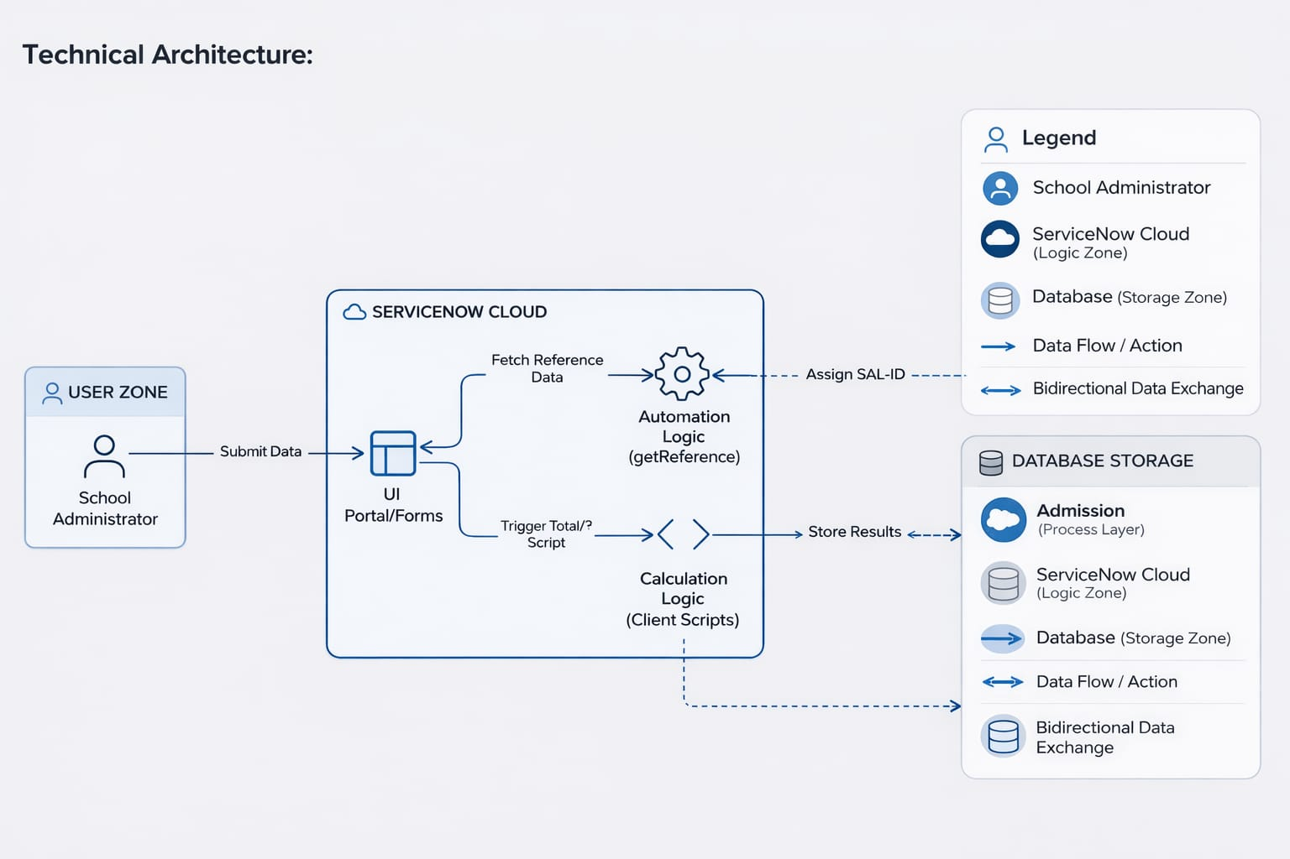
Table-1 : Components & Technologies:
S.No | Component | Description | Technology
1 | User Interface | Interface through which the School Administrator interacts with student records. | ServiceNow Service Portal & Workspace UI (HTML, CSS, AngularJS)
2 | Application Logic-1 | Automated calculation of Total Marks, Percentage, and Results. | ServiceNow Client Scripts (JavaScript)
3 | Application Logic-2 | Retrieval and auto-population of student data. | GlideAjax & getReference (JavaScript)
4 | Application Logic-3 | Visual monitoring of admission lifecycle stages. | Process Flow Formatter (ServiceNow Native)
5 | Database | Storage of Master Registry, Admission, and Evaluation records. | ServiceNow Relational Database (MariaDB based)
6 | Cloud Database | Centralized storage and accessibility of academic data. | ServiceNow Cloud (PDI)
7 | Infrastructure | Development and deployment environment. | ServiceNow Personal Developer Instance (PDI)

Table-2: Application Characteristics:
S.No | Characteristics | Description | Technology
1 | Open-Source Frameworks | Scripting and UI frameworks supporting system customization. | JavaScript (ES6), AngularJS
2 | Security Implementations | Protection of sensitive student evaluation data. | ACLs (Access Control Lists), Read-only/Disabled UI Policies
3 | Scalable Architecture | 3-tier architecture separating UI, Logic, and Data layers. | ServiceNow Multi-instance Architecture
4 | Availability | Continuous accessibility of the school management system. | ServiceNow Cloud Infrastructure (High Availability)
5 | Performance | Efficient execution of real-time calculations and data fetching. | Asynchronous Client Scripts (GlideAjax)

